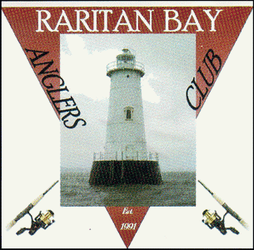 RARITAN BAY ANGLERS CLUB
APPLICATION FOR MEMBERSHIP
DATE: _____________________
NAME: _____________________________________________________________________
ADDRESS: ___________________________________________________________________
___________________________________________________________________
OCCUPATION: _______________________________________________________________
HOME PHONE: _________________________ CELL PHONE: ___________________________
EMAIL ADDRESS: ______________________________________________________________
ARE YOU RELATED TO A MEMBER? YES / NO (PLEASE CIRCLE)
IF YES, WHO AND HOW ARE YOU RELATED? ________________________________________
ARE YOU A FRIEND OF A MEMBER? YES / NO IF YES, WHO? ___________________________
DO YOU OWN A BOAT? YES / NO NAME OF YOUR BOAT: _____________________________
IF YES: YEAR ___________ MAKE _____________________ MODEL _____________________
WHAT TYPE OF FISHING DO YOU DO? SALTWATER / FRESHWATER / BOTH (PLEASE CIRCLE)
WHAT IS YOUR REASON FOR WANTING TO JOIN THIS CLUB? _______________________________________________________________________________________________________________________________________________________________________________________________________________________________________
WHAT ARE YOUR EXPECTATIONS OF THIS CLUB IF YOU ARE VOTED IN? _______________________________________________________________________________________________________________________________________________________________________________________________________________________________________
PLEASE EMAIL YOUR COMPLETED APPLICATION TO: rbacmembership@gmail.com

